Client-Server Architecture

The web is a service that allows us to access and share data on the internet. In order to achieve this, two kinds of architectures are used: Client-server and Peer - to - peer model.

The client is the machine from which the request is made. It can be a computer, a mobile phone, a smartwatch, etc.

The program through which the request is made is called the client program. A standard example of a client program is a web browser. But there can be others like any online game, or any application that works online.

The server is a computer program and not a device. The large computers that normally run these sever programs are called server computers. But any computer can be made a server computer by running the server program.

The server does the job of responding to the requests of the client. It can serve multiple clients simultaneously.

The client-server architecture works by the interaction of the client with the server and sometimes between server-server also by the concept of master and slave servers.

[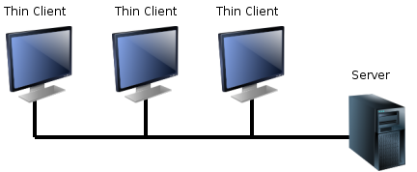](https://commons.wikimedia.org/wiki/File:Thin_clients.png)

Basics of cloud computing

In the early days of the internet, the companies would set up and manage their own servers. But, as the amount of data being generated started increasing, things, like managing the servers and scaling, became a headache, especially for the smaller players of the game.

Soon, a few big companies came up with the idea of selling computation power as a commodity and cloud computing was born.

**What is cloud computing?**

Cloud computing could be defined as the practice of storing, processing and accessing data/applications from remote servers via the internet.

**Service Models**

The cloud supports mainly three kinds of service models:

* Saas: It stands for software as a service. Softwares hosted on servers can be used by users without having to install the software on their systems. Example: Google docs.
* Paas: It stands for platform as service. It gives developers platforms to build their applications. Example: Google app engine.
* Iaas: Infrastructure as a service allows users to use the computing resources of the server. Example: AWS EC2.

History of cloud computing

1961: John McCarthy in a speech at MIT introduced the idea of cloud computing but due to lack of technology no development in this field was done.

But as companies started to invest in wired and wireless communications, and greater internet speeds were achieved, as well as computing evolved, cloud computing came in its early phase.

1999: Salesforce.com was founded by three men with the aim of creating business software applications in a completely new way, to deliver software through a model known as Software-as-a-Service. This completely eliminated the need for multimillion-dollar upfront costs, implementations that could take years and for the ongoing complexities of maintenance and constant upgrades.

2002: AWS was launched as a free service that allowed companies to incorporate amazon.com features on their own sites.

2006: AWS launched its first cloud products, enabling businesses to build their own applications using Amazon’s infrastructure. The two services launched at this time were Simple Storage Service(S3) and Elastic Compute Cloud(EC2).

2008: Google joins the competition, providing cloud computing enterprise applications.

2009: Microsoft launched Azure and companies like HP and Oracle joined the game.

2011: IBM announced the IBM SmartCloud framework to support Smarter Planet.[35] Among the various components of the Smarter Computing foundation, cloud computing is a critical part.

2012: Google Compute Engine was released in preview, before being rolled out into General Availability in December 2013.

2019: In 2019, it was revealed that Linux is most used on Microsoft Azure.

Why cloud computing?

Cloud computing allows companies to take advantage of the superior computing power of the server computers of big enterprises. This saves them the effort of setting up their own servers. Companies can spend more time and resources in growing their business without worrying about things like maintenance of the servers, troubleshooting, and scaling. It is also a much more economical solution than setting up own servers because it works on a pay-per-use model, i.e. the user or company only has to pay for their usage, much like an electricity bill.

Cloud Computing Architecture

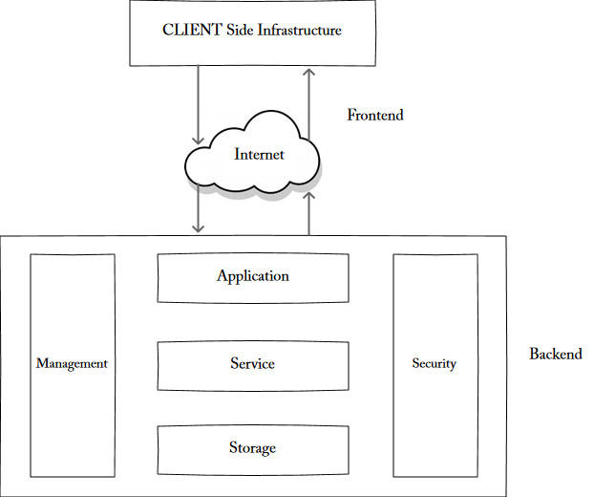

The cloud architecture can be broadly divided into two parts:

* Front end
* Back end

**Front End:** It is the interface through which the client makes requests and interacts with the cloud.

**Back End:** It is the responsibility of the back-end to provide the security of data for cloud users along with the traffic control mechanism. The server also provides the middleware which helps to connect devices & communicate with each other.

Advantages of Cloud Computing

1. **Backup and recovery:** As all the data is stored on the servers with virtually infinite storage capacity, it makes it really easy to make copies and backups of all the data and recover it when needed.
2. **Accessibility:** The servers providing cloud services normally have up to 99% uptime, meaning that they can be accessed almost any time needed.
3. **Unlimited Storage:** The enterprise servers have virtually unlimited storage capacity. In order for an organization making use of cloud services to increase their storage capacity, they simply need to change their plan and pay the amount needed to the cloud service provider.
4. **Cost Saving:** As the cloud services work on a pay-per-use model, the organizations only need to pay as much as they use the service, this makes it really cost-effective. On top of that, the organizations also don’t need to spend money on setting up their own servers and maintaining them.
5. **Reliability:** The cloud service providers take care of the security and management of resources, which makes them very reliable.

Disadvantages of Cloud Computing

1. **Security:** As all our organization’s sensitive information is stored on some other company’s computers, we are putting ourselves at a risk. Therefore it is important to choose a reliable cloud service provider.
2. **Accessibility:** Network issues can make cloud unaccessible.
3. **Downtime:** Cloud service providers take care of a number of clients each day, so sometimes this heavy load can lead to business processes being temporarily suspended.
4. **Lock-in:** It is very difficult for an organization to shift from one cloud service provider to another, which leads to a lock-in, i.e. a company is stuck with the current cloud service provider unless it decides to go through the heavy task of moving from one provider to another.

Deployment Models

A cloud deployment model is defined according to where the infrastructure for the deployment resides and who has control over that infrastructure. There are four cloud deployment models: public clouds, private clouds, community clouds, and hybrid clouds.

* **Public cloud:** It allows users to use resources from a common server shared by other users.
* **Private cloud:** This is the infrastructure used by a single organization. It may be managed by the organization itself or by a service provider that takes care of it either on-site or off-site.
* **Hybrid cloud:** In a hybrid cloud, an organization makes use of interconnected private and public cloud infrastructure. Many organizations make use of this model when they need to scale up their IT infrastructure rapidly, such as when leveraging public clouds to supplement the capacity available within a private cloud.
* **Community cloud:** This deployment model supports multiple organizations sharing computing resources that are part of a community; examples include universities cooperating in certain areas of research, or police departments within a county or state sharing computing resources. Access to a community cloud environment is typically restricted to the members of the community.

Cloud Services

Based on different delivery models, different types of cloud services are available.

Saas:

* Entire Google Ecosystem.
* Microsoft Office 365
* HR help desk
* Salesforce

Paas:

* AWS Elastic Beanstalk
* Google app engine
* Heroku
* Azure

Iaas:

* Aws ec2
* Gogrid
* Rackspace

Cloud Service Providers

Major cloud service providers are:

* Aws
* iCloud
* Azure
* Google cloud
* Ibm smart cloud